` **IWT ASSIGNMENT-2**

(By Team-7)

**PS2:** Develop a web application to create a Calorie Tracker Web Application using Django Framework.

**Developed by:**

1) Aadarsh Pokala (21)

2) Adarsh Kumar Akula (22)

3) Aman Rachala (23)

4) Chetan Pande (27)

5) Dhanush Burra (28)

6) Gokul Chinthalapudi (31)

**Acknowledgements:**

We would like to express our gratitude and special thanks to our IWT Shri R Srikanth sir who gave us a wonderful opportunity to do this assignment in a unique way ie. to prepare a web application of calorie tracker, which helped to gain a lot of knowledge and real life applications about the django framework. We learnt a lot of new things regarding the technologies used in this project.

**Abstract:**

The project is a web application. This is a project for providing the calorie intake of a user based on the food item information provided by him/her to the system. Also, the system shall provide a detailed data of the nutrient constitution of the food item entered by the user. There is a need for maintaining track of a person’s daily food habits and accordingly formulate a desirable diet to maintain a healthy lifestyle. However, these functionalities are barely available under one roof. This application fulfills that requirement of a user. The web application takes the food items as input and calculates the calories consumed by the user. This allows user to maintain a healthy diet.

**Objectives of the project :**

i) Create a web application to track calorie intake

ii) Also provide personalized assistance to each user with a daily calorie intake limit as specified by the user

iii)Store the user details in a database

iv)Add the user profile where he/she can enter the type of food and the calories it provides

v) Edit the diet plan for user and add or remove the necessary food items

**Technologies used:**

**Frontend:** HTML,CSS and Javascript

**Backend:** Django Framework

**Introduction**:

The application in subject, provides a means for keeping a check on a person's daily eating habits by providing calorie intake information. The application tracks a user’s whole day consumption of food.

Calorie calculation is the process of measuring the nutrient intake of a person based on the foods he/she consumes, which in turn helps to maintain an energy balance between what the daily eating habits are and what they need to be. A user will login to the system. Once logged in, he can update his calorie intake information by entering the food items he consumed today thereby obtaining the total calorie intake information in terms of necessary nutrients namely proteins, fats and carbs. The whole day’s intake is recorded as per the time when it is entered by the user.

**Basic features:**

* Tracking calories
* Custom foods
* Food entry
* Analysis screen
* Login page
* Entering Food amount
* Calorie goals

**Target Audience:**

* Athletes
* Film stars
* Senior citizens
* Patients

**Output:**

**Login Page:**

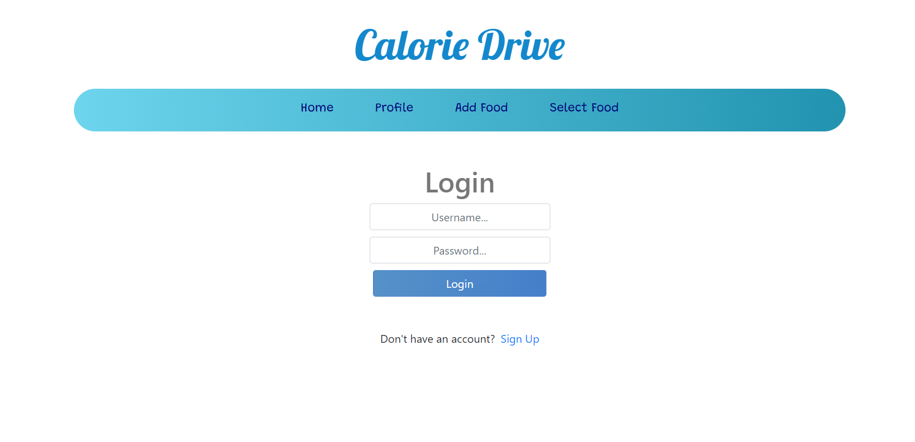

**We can add food that we eat regularly:**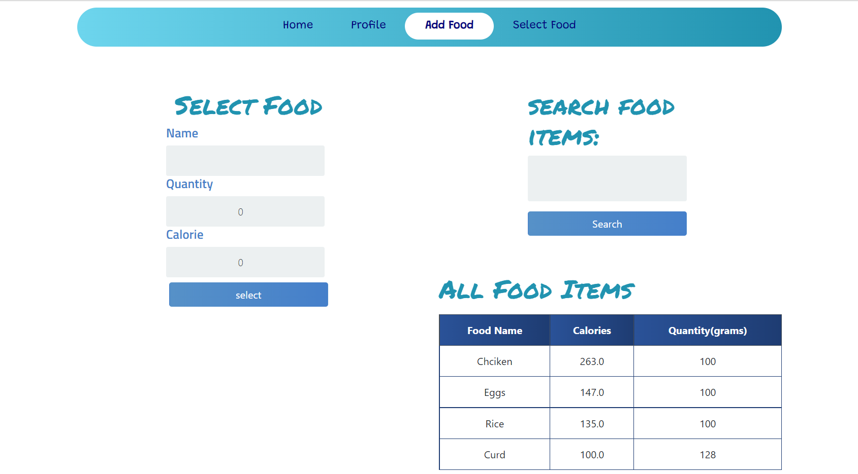

**We can set calorie goal every day and also store the daily data:**

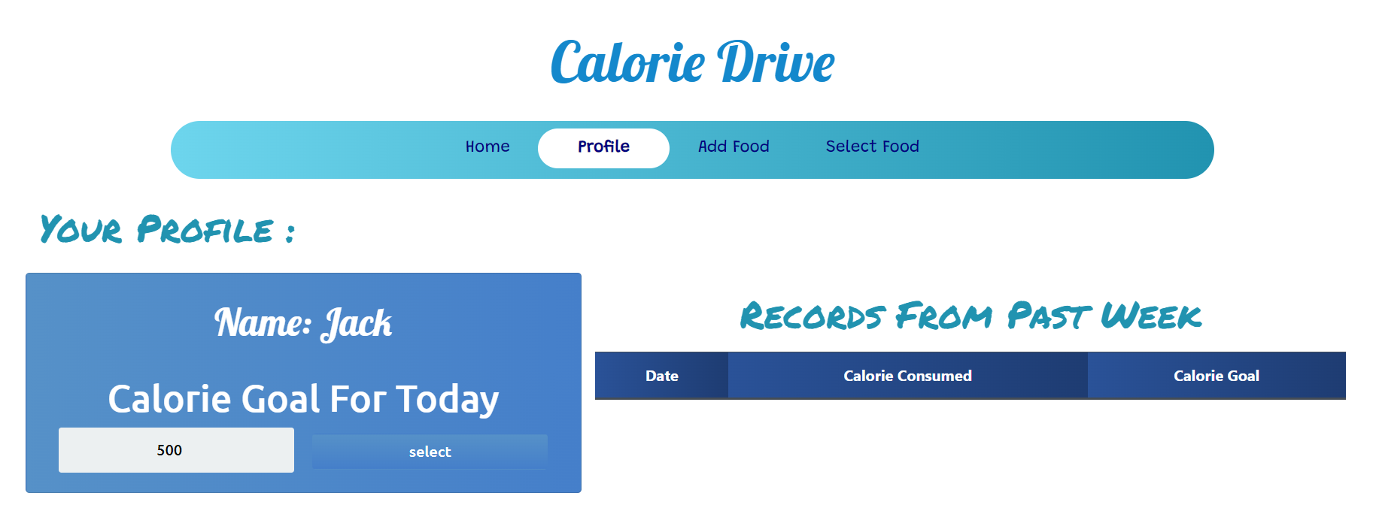

**We can update or delete the food items as we want:**

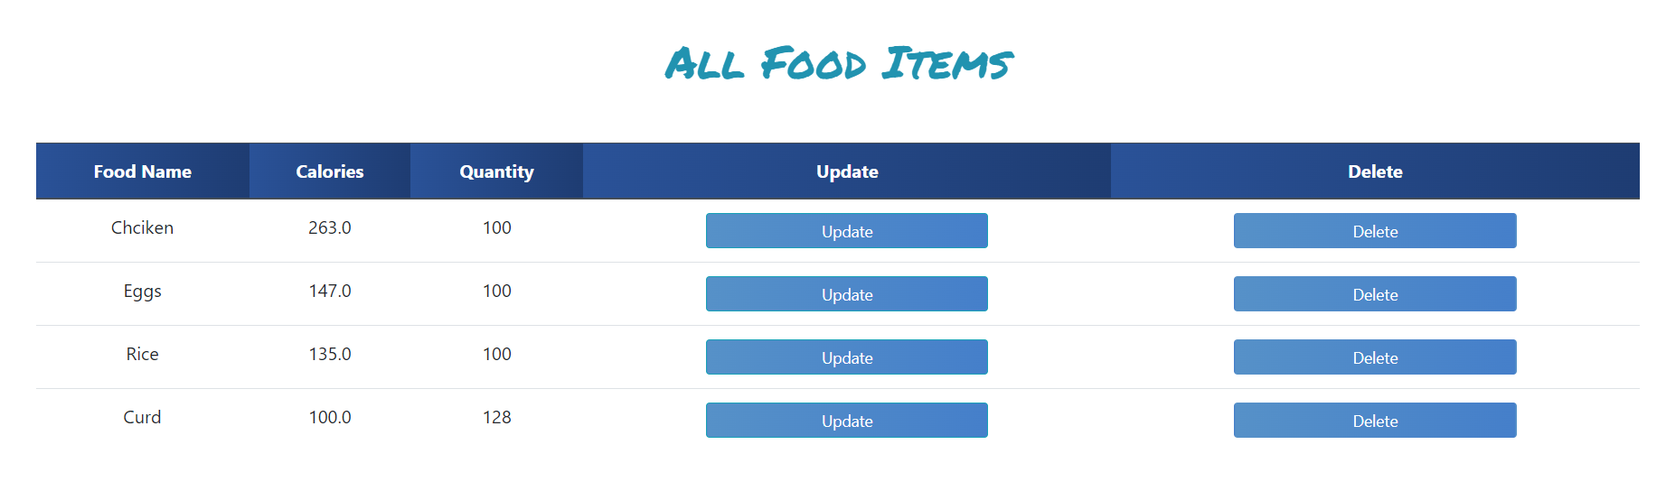

**Now we can select the food we ate and give the quantity :**

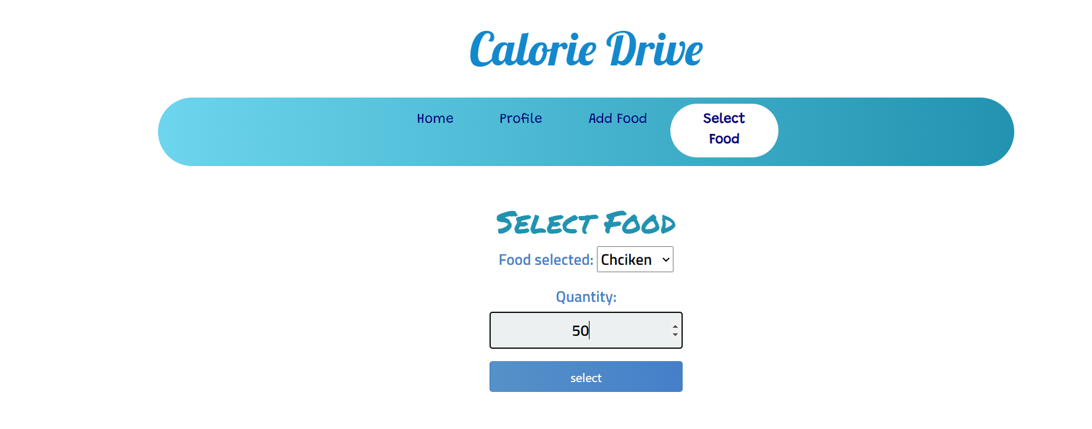

**This reflects in the home page:**

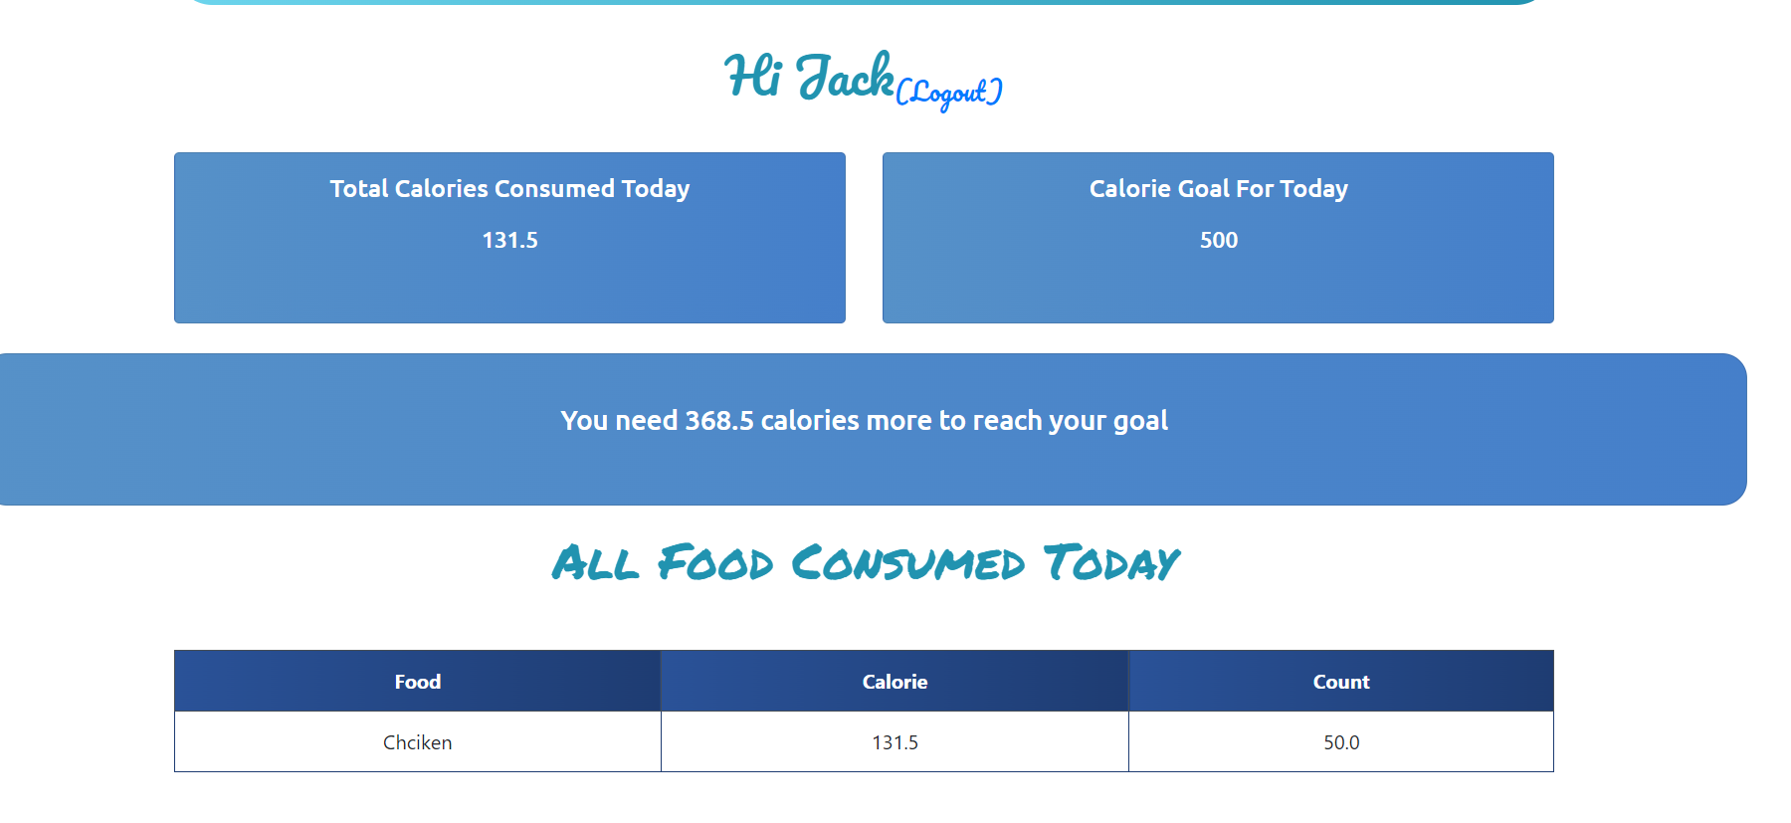

**Database design:**

Data is stored in sql lite which can be accessed by “local server/admin” which can be seen as

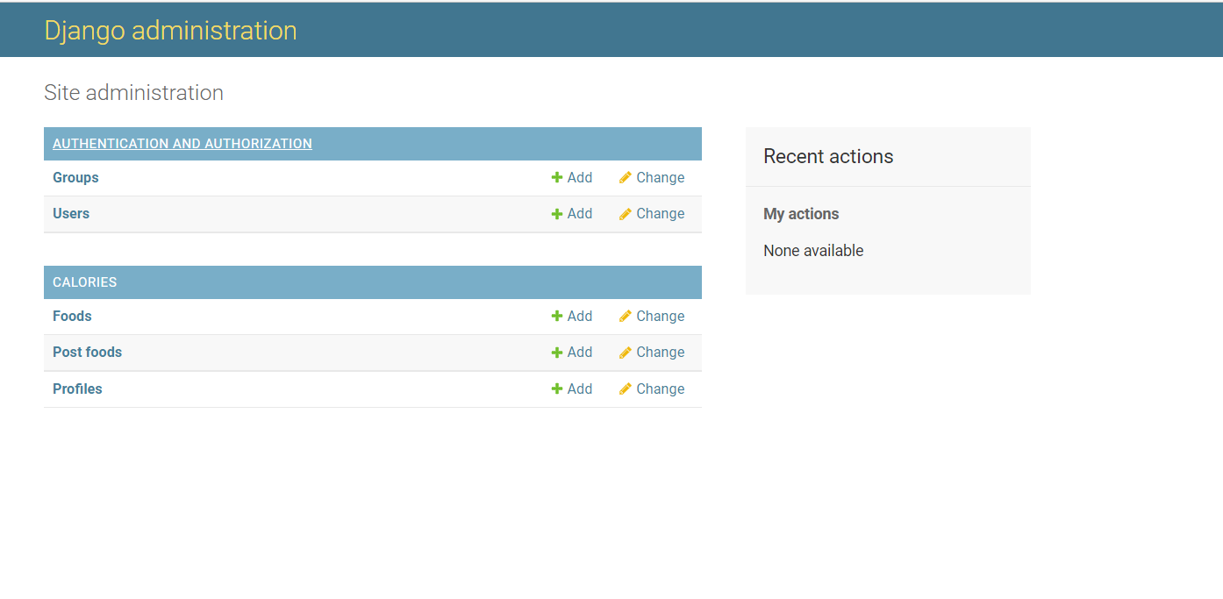

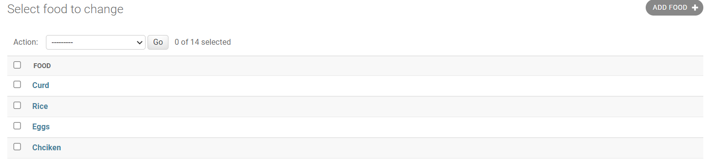

**Future Scope:**

1) It can be further developed to give diet information for a healthy diet menu.

2) We can create a health tracking profile for every user based on their diet intake.

3) Suggesting different foods to each individual based on their health reports.

**Conclusion:**

This application of calorie intake calculation and diet check, thus provides the complete information regarding calorie intake of the user as per the user-consumed and user-entered food items for the day. Thus the application stands out different from other applications by being a substitute to the actual dietician by providing a proper and accurate calorie calculation and suggestion information.